

Best Practices Website

CSRIC User Guide

July 2019

Table of Contents

1. Introduction 3

2. General Use 3

3. System Access 3

3.1 Account Access 3

3.2 Logging in 3

4. Best Practice Proposals 4

4.1 Propose New Best Practice 4

4.2 Steps for the User to Propose a Best Practice 5

4.3 Edit Existing Best Practice 6

4.4 Steps for the User to Edit a Best Practice 7

4.5 Recommend Deletion of Best Practice 10

4.6 Steps for the User to Delete a Best Practice 10

5. Other Features 11

5.1 Withdraw proposal 11

5.2 Steps for the User to Withdraw a Best Practice 11

5.3 Transfer Control 12

5.4 Steps for the User to Transfer Control of a Best Practice 12

5.5 Edit Transferred Best Practice 13

5.6 Steps for Editing a Transferred Best Practice 13

# Introduction

This User Guide provides instructions on how to operate and navigate the ATIS Best Practices website. It provides step-by-step instructions for CSRIC and other account users to propose new Best Practices, propose modifications to existing Best Practices, or recommend the deletion of Best Practices.

# General Use

A user account is not required to search, view, or export Best Practices. A separate General User Guide has been developed with instructions on searching, viewing, and exporting Best Practices.

# System Access

## **Account Access**

The website requires a user account in order to propose new Best Practices, propose modifications to existing Best Practices, or recommend the deletion of Best Practices.

It is desired that a representative from each CSRIC WG establish an account in order to make Best Practice submissions. A user must contact ATIS in order to establish an account. Requests for accounts should be sent to [jwohlgemuth@atis.org](mailto:jwohlgemuth@atis.org). The user should provide the WG they represent as well as a desired Username. The user will receive an email once their account is established.

## **Logging in**

Once a user account is established, the user can login to the website (<https://bp.atis.org/>) by clicking “Login” on the top right side of the Best Practice home page. Enter your Username and Password and select Submit. If you have forgotten your password, you can click the “Forgot Password” link. You will be asked to enter the email address used to create your Best Practice Login. You will receive an email with your Username and a link to reset your password. Once your password has been reset, a link to login to the system is displayed at which point you can access the Best Practices Website.

Once logged in, the menu bar has two additional options—1) Propose a Best Practice, and 2) User Profile.

# Best Practice Proposals

## **Propose New Best Practice**

The system will guide the user through the process of developing a well-formed Best Practice. The Generate Best Practice page has eight sections:

* Category
* Industry Roles
* Network Types
* Keywords
* Description
* References/Comments
* Workgroup
* Category (for BP number assignment)

Definitions for the options within the first four categories above are obtained by hovering your cursor over the information icon on the “Generate Best Practice” screen. This information is also available in the [Best Practice Tutorial](https://bp.atis.org/tutorial/).

The following rules exist for proposing a Best Practice:

* The user must select one of the following categories: Standard or Public Safety & Disaster
* The user must select one or more Industry Roles
* The user must select one or more Network Types
* The user must select one or more Keywords

The first line of the Description field is auto populated depending on the Industry Roles selected by the user. There is a hierarchy to the order in which the Industry Roles are placed in the first segment of the Best Practice Description (Network Operators, Service Providers, Equipment Suppliers, Property Managers, Public Safety and Government). The order of the Industry Roles is not dependent on the order in which they are selected on the screen. Following selection of the Industry Roles, the system will auto-populate “should”, the modifier for the Best Practice. The user should then enter the “what” of the Best Practice in the second Description field. The system will form the Best Practice based on the user entries.

Note: Proposing a Best Practice that is not in conformance with the format for Best Practices will cause system errors when processing the file. As a reminder, Best Practices should be in the format of “Industry Role(s)” ”should” “Description”. Entering punctuation in the first position of the Description field, such as a comma, will also create a system error when processing the file (e.g. placing a comma after “should” in a Best Practice: Service Providers should, if necessary, …). For more information on the format of a Best Practice, please review the Best Practices Tutorial at https://bp.atis.org/tutorial/.

The user should populate “References/Comments” associated with the Best Practice in the “References/Comments” field. No references or commentary information should be contained within the Best Practice Description field.

The user should select the CSRIC WG proposing this Best Practice.

Finally, the user should select the appropriate Category for the proposed Best Practice. Special consideration should be given to ensuring this field is accurately populated as it will impact the auto-assignment of a Best Practice Number. If you have any questions regarding the assignment, please contact John Healy or Jackie Wohlgemuth.

The addition of the proposed Best Practice will not be effective or updated in the database until approved by the CSRIC, coordinated with the FCC, and processed by ATIS staff.

## **Steps for the User to Propose a Best Practice**

Step 1: After login, select “Propose Best Practice” from the navigation bar.

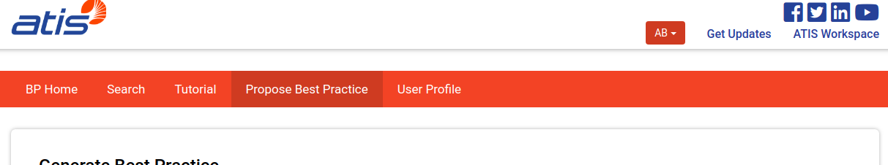

Step 2: Select whether the Best Practice is a Standard Best Practice or related to Public Safety & Disaster. Additionally, select the appropriate Industry Role(s), Network Type(s), and Keyword(s) associated with the new proposed Best Practice. The system automatically populates the beginning of the description of the Best Practice based on the Industry Roles selected. Complete the remainder of the description of the Best Practice. Continue to complete the References/Comments field, select the WG submitting this proposed Best Practice and select the category for the Best Practice that will determine the last segment of the Best Practice Number.

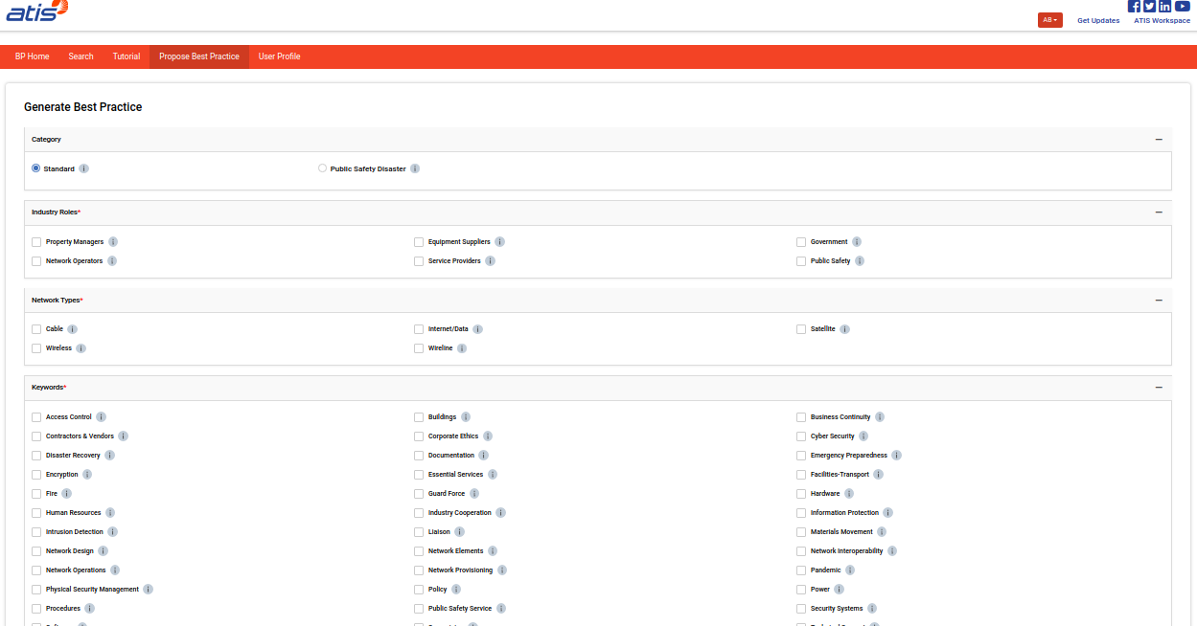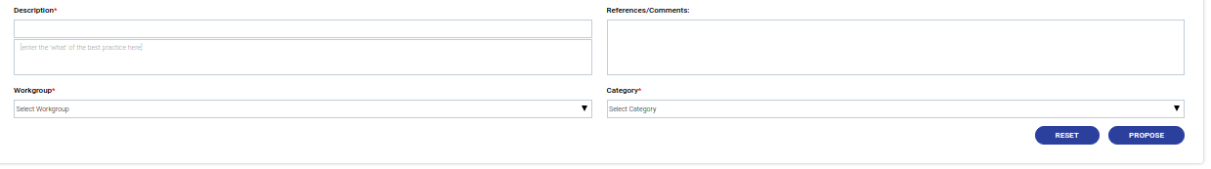

Step 3: Press “Propose” to submit the Best Practice. The following will display after selecting Propose.

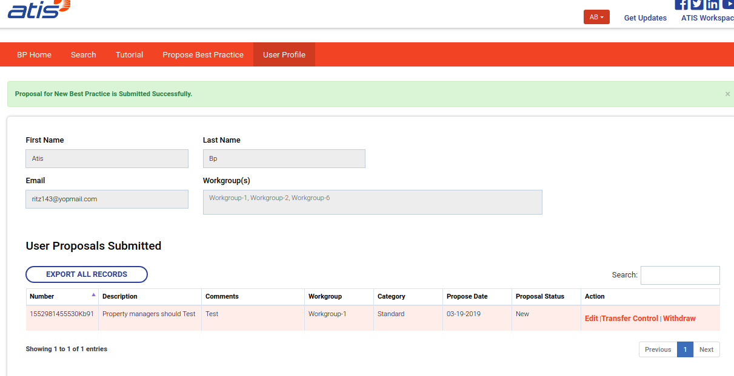

## **Edit Existing Best Practice**

Users can propose edits to existing Best Practices within the system. The edits will not be effective or updated in the database until approved by the CSRIC, coordinated with the FCC, and processed by ATIS staff. Changes can be made to any of the following elements of a Best Practice:

* Category
* Industry Roles
* Network Types
* Keywords
* Description
* References/Comments
* Workgroup

Changes cannot be made to the category that influences the Best Practice Number. If the Best Practice needs to be recategorized/renumbered, the existing Best Practice should be deleted, and a new Best Practice proposed.

Definitions for the options within the first four categories above are obtained by hovering your cursor over the information icon on the “Edit Proposal for Best Practice Number XX-XX-XXXX” screen. This information is also available in the [Best Practice Tutorial](https://bp.atis.org/tutorial/).

The following rules exist for editing a Best Practice:

* The Best Practice must contain one of the following categories: Standard or Public Safety & Disaster
* The Best Practice must contain one or more Industry Roles
* The Best Practice must contain one or more Network Types
* The Best Practice must contain one or more Keywords

The first line of the Description field will auto-populate based on any changes made to the Industry Roles selected by the user. There is a hierarchy to the order in which the Industry Roles are placed in the first segment of the Best Practice Description (Network Operators, Service Providers, Equipment Suppliers, Property Managers, Public Safety and Government). The order of the Industry Roles is not dependent on the order in which they are selected on the screen. Following selection of the Industry Roles, the system will auto-populate “should”, the modifier for the Best Practice.

The user should select the CSRIC WG proposing this Best Practice and “Submit” the edited Best Practice.

This Best Practice can be edited multiple times by the same user by searching on the Best Practice again or accessing it from the User Profile.

## **Steps for the User to Edit a Best Practice**

Step 1: After login, perform a search on the Best Practice you wish to edit.

Step 2: Select “Edit” as the proposed action.

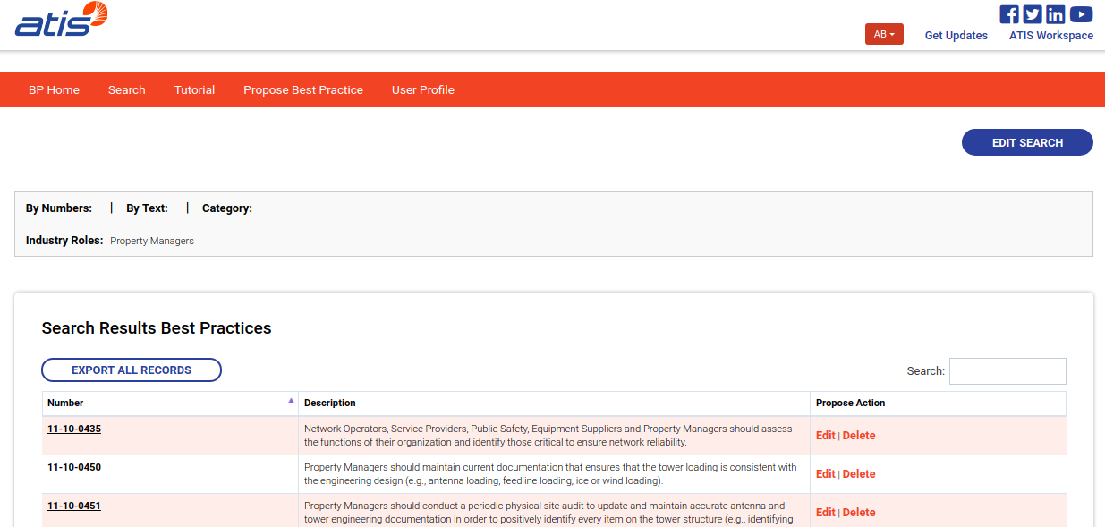

Step 3: The system will pre-populate the information for the existing Best Practice in the form. The user can then make changes to any of the following sections:

* Category
* Industry Roles
* Network Types
* Keywords
* Description
* References/Comments
* Workgroup

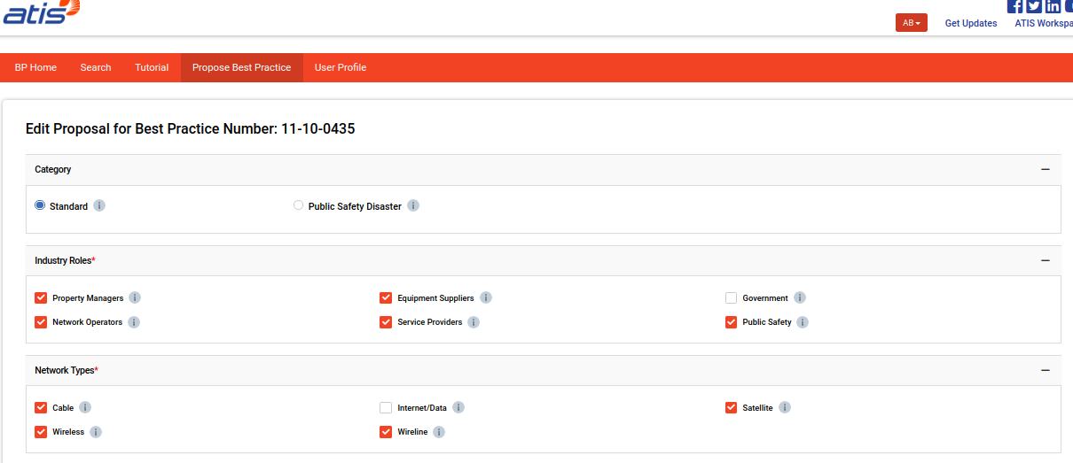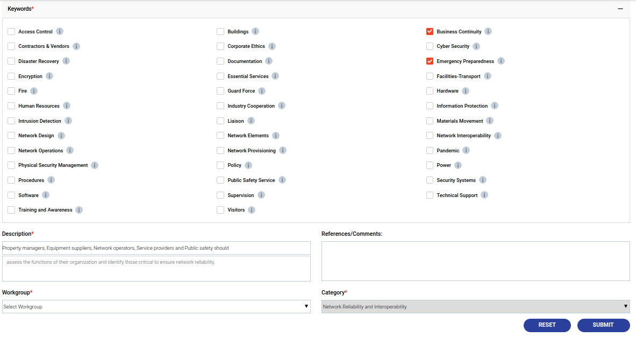

Step 4: Once the edits are completed, and the WG has been selected, select “Submit”. The user will receive the following screen.

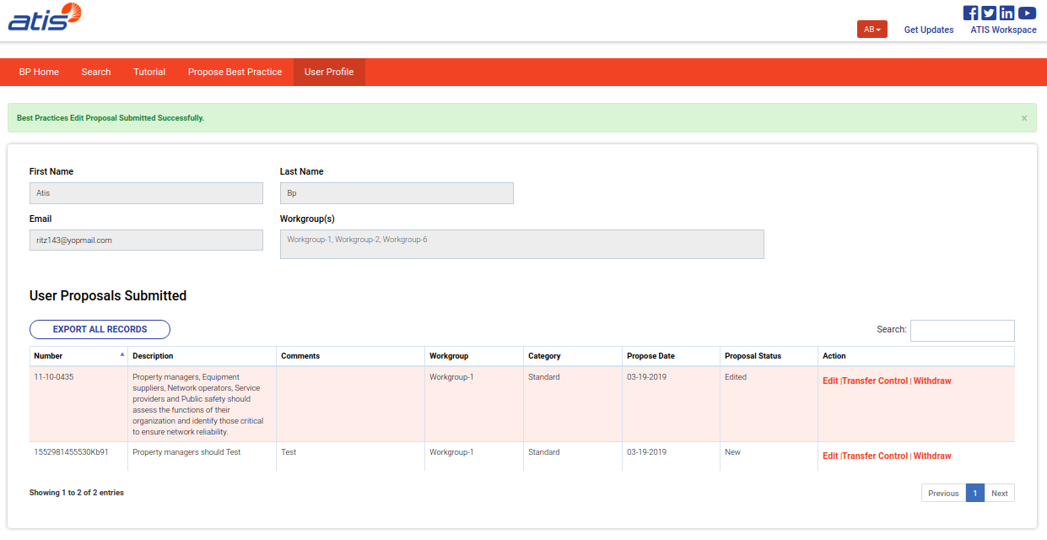

## **Recommend Deletion of Best Practice**

Users can recommend the deletion of a Best Practice(s) within the system. The recommendation may be the result of a stale Best Practice, a duplicate or similar Best Practice has been identified or is being proposed, new technology may need to be addressed or any other various other reasons. The deletion will not be effective or updated in the database until approved by the CSRIC, coordinated with the FCC and processed by ATIS staff.

## **Steps for the User to Delete a Best Practice**

Step 1: After login, perform a search on the Best Practice you wish to delete.

Step 2: Select “Delete” as the proposed action.



Step 3: Enter the WG requesting the deletion and select “Propose Delete”. The user will receive the following screen:

# Other Features

## **Withdraw proposal**

Users can withdraw proposed Best Practices. In the event a user has proposed a new Best Practice, edited a Best Practice or recommended a Best Practice for deletion and wished to retract that proposal, the “withdraw” feature should be used. The withdraw request may be the result of an error, the CSRIC WG not approving the recommendation to the Best Practice, or some other reason. The withdrawn Best Practice will no longer be considered for action during this CSRIC and the Best Practice will remain in the database unedited.

## **Steps for the User to Withdraw a Best Practice**

Step 1: After login, perform a search on the Best Practice you wish to withdraw. Alternatively, the user can access the User Profile and find all Best Practices they have proposed for action during this CSRIC.

Step 2: Select “Withdraw”. Review the Best Practice and select “Withdraw Proposal”.

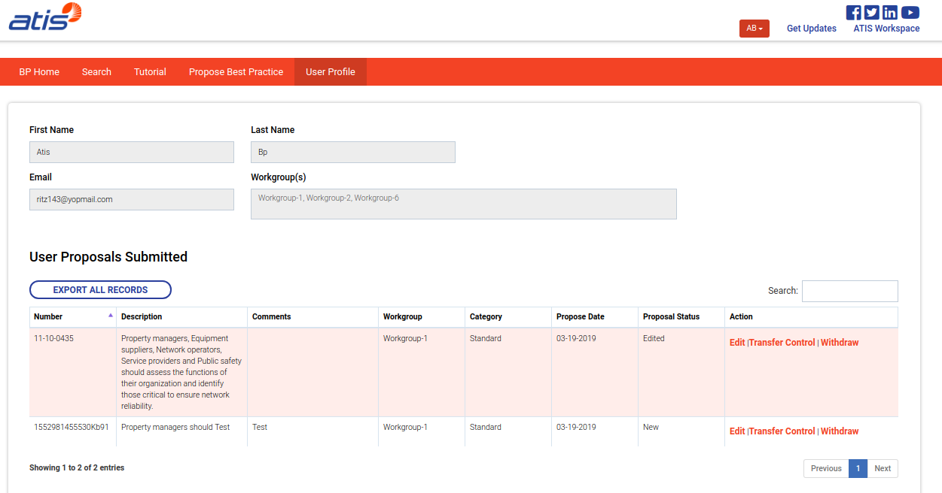

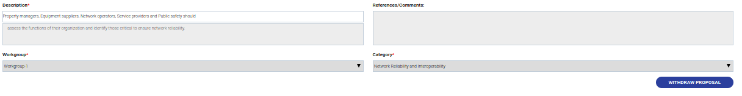

The user will receive the following screen:

The user will then receive the following confirmation screen:

## **Transfer Control**

Users can transfer control of activity on a Best Practice to another user. The transfer may be the result of changing responsibilities, another CSRIC WG may wish to assume activity for the Best Practice, or some other reason.

## **Steps for the User to Transfer Control of a Best Practice**

Step 1: After login, perform a search on the Best Practice you wish to transfer control. Alternatively, the user can access the User Profile and find all Best Practices they have proposed for action during this CSRIC.

Step 2: Select “Transfer Control”.



Step 3: A pop-up will open, and the user should select the Username and WG to which the Best Practice will be transferred. Select “Submit” and this will transfer the Best Practice to the selected user, and it will be visible on profile of that user.

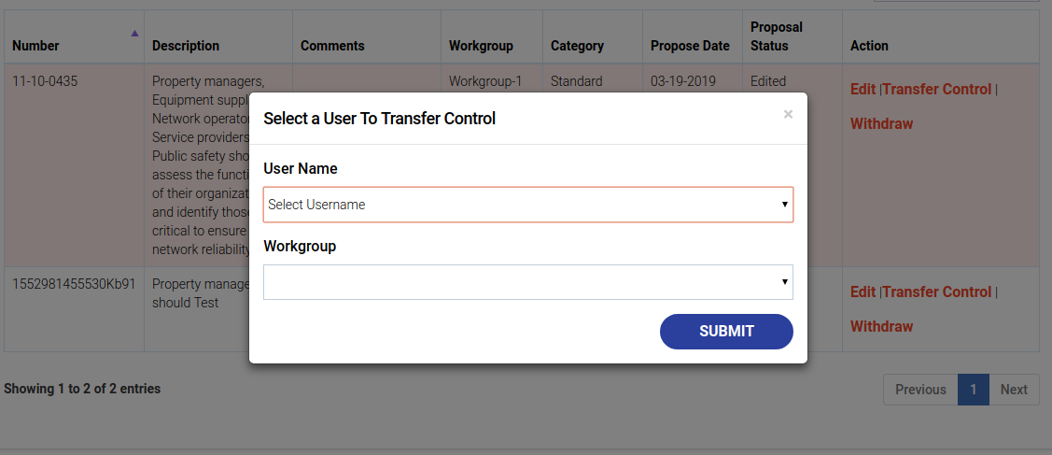

## **Edit Transferred Best Practice**

Once a user receives a Best Practice transferred from another user, the Best Practice is now under control of the new user. Any additional changes can be made to the Best Practice.

## **Steps for Editing a Transferred Best Practice**

Step 1: After login, perform a search on the Best Practice you wish to edit. Alternatively, the user can access the transferred Best Practice under the User Profile.

Step 2: Refer to Steps 2-4 under “Steps for the User to Edit a Best Practice”.